Subject: Fresno County Residents Council Update 10.6.21

Tagline: Training #2 Follow Up and Next Steps

Hi

I hope you are doing well and staying safe. It was a pleasure to see most of you at the second training of the Fresno Residents Council- "Community Organizing"! In training #2, we learned:

* The importance of building public relationships in order to build a powerful community.
* We can build trusting relationships through one-on-one meetings called relational meetings.
* We can get to know what is important to someone by following the "[Stick Figure](https://drive.google.com/drive/u/0/folders/1KJB0B6vReIQjxKavFtKeT3dgMRvLhSCY)" template which outlines different types of relationships and connections a person can have.
* We must seek to build trusting relationships with each other before we can start to effectively organize around solving the problems in our community.

**Reminder:** If you were unable to attend any training, you can [watch the video](https://drive.google.com/drive/u/0/folders/1DpVOGFkhUktEQkAaywxT9bVtxXllTFhH)! Let your Anchor Organization know once you have watched the full video so that it will count as your attendance.

*You can view the PowerPoint Presentations, recordings, and documents through the "Meeting Documents" button below.*

***This months homework assignment*** *is to connect with another person in your Anchor Organization or another member of the Council and have one-on-one conversations using the concepts and stick figure we shared with you during the training.* ***Please remember to submit your homework to your Anchor Organization by Wednesday, October 13th.***

*We would like to reiterate the wise words of Hope Flint from our Tuesday Training:*

*"People may come to an event for the incentives, but they will MARCH for relationships."*

Our next training will be on Tuesday, October 19th from 5:30-7pm or Saturday, October 23rd from 10-11:30am. All trainings are Virtual sessions on ZOOM.

Be sure to register by selecting the date you are able to attend below. For translation services, you must register by Friday, October 15th and let us know which language translation you are needing.

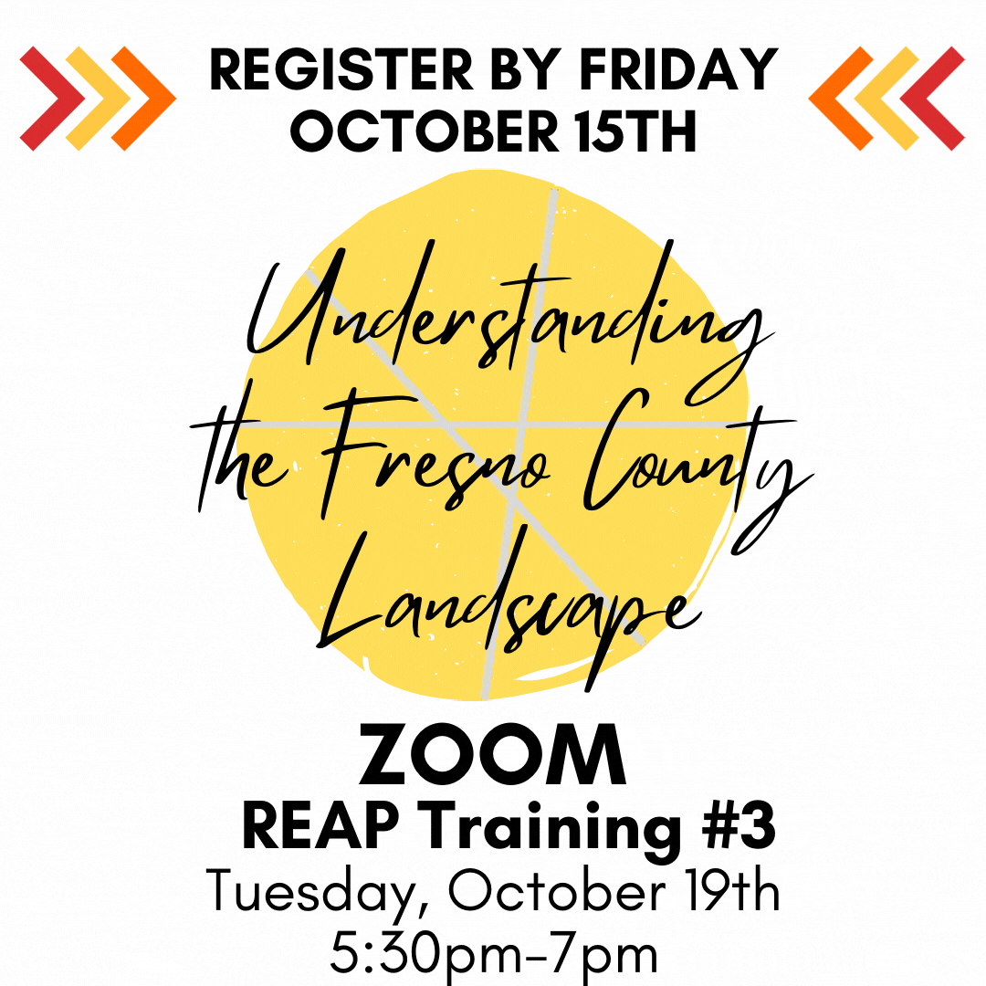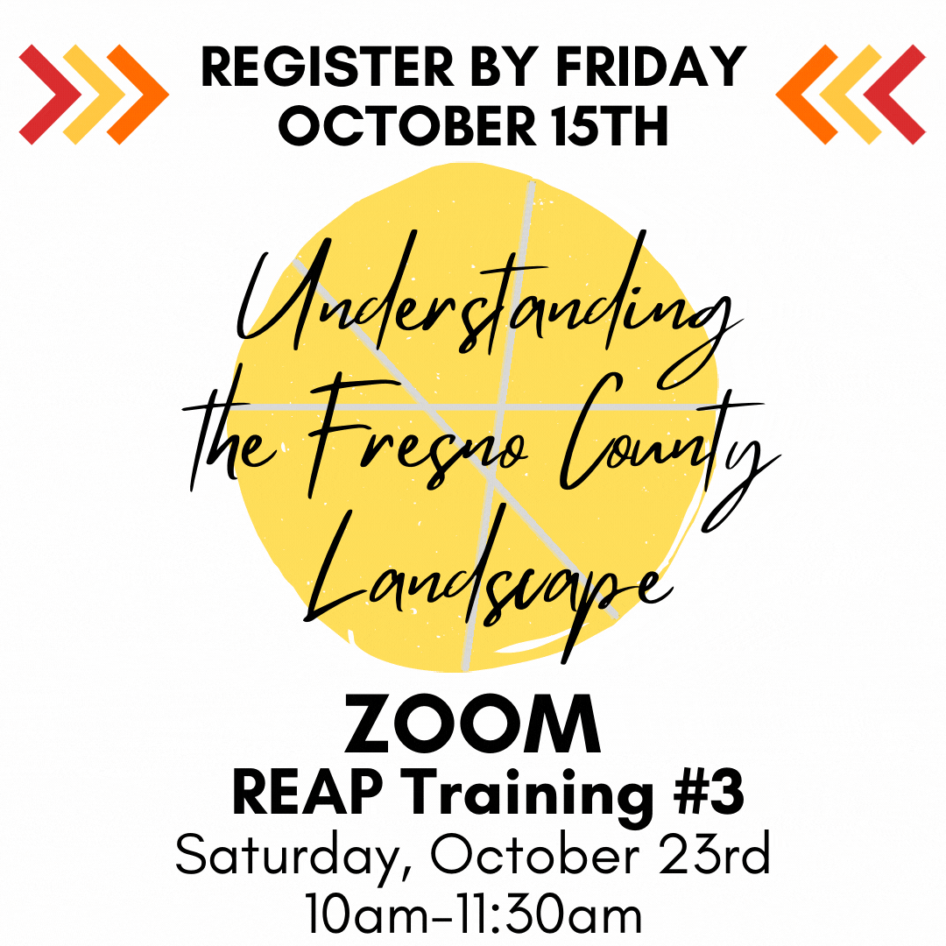

As we continue on this journey together, we would like to make sure Fresno County knows about the amazing work we are doing. We would like to capture photos and videos to tell the story of the first ever, Fresno Residents Council. To be included in this digital story, please be sure to fill out and submit a [Media Release form](https://drive.google.com/drive/u/0/folders/1fzD9QXtH7qOC6fw-qGnR0x9E-lvruVIt) to [pen@tcmfresno.org](mailto:pen@tcmfresno.org).

We look forward to seeing you soon!

In Community,

Mike Espinoza

Director, The Children’s Movement of Fresno